|  |  |  |  |  |  |
| --- | --- | --- | --- | --- | --- |
| Date | 7-Dec-22 | | | Tester Name | Andrew McLaughlin |
| Environment | Penfax - Test | | | Login used |  |
| Operating System | Windows | Version: | Update: | | |
| Software Used | Edge | Version: | Update: | | |
| Select Software | Version: | Update: | | |
| Release version | 22.4.1 | | | | |
| Title | Run the Actuarial Extract to confirm no changes | | | | |
| Test Type | Regression | | | | |
| Test Scenario | Run the Actuarial Extract to confirm no changes | | | | |
|  |  | | | | |
| Expected Results |  | | | | |
| Pass/Fail | Pass | | | JIRA# | N/A |

Describe your steps with screenshots:

Run the Actuarial batch for All MEPP to match the last real extract available (01-JAN-2021 – 31-DEC-2021 in this case) after work hours to ensure system performance is not affected. 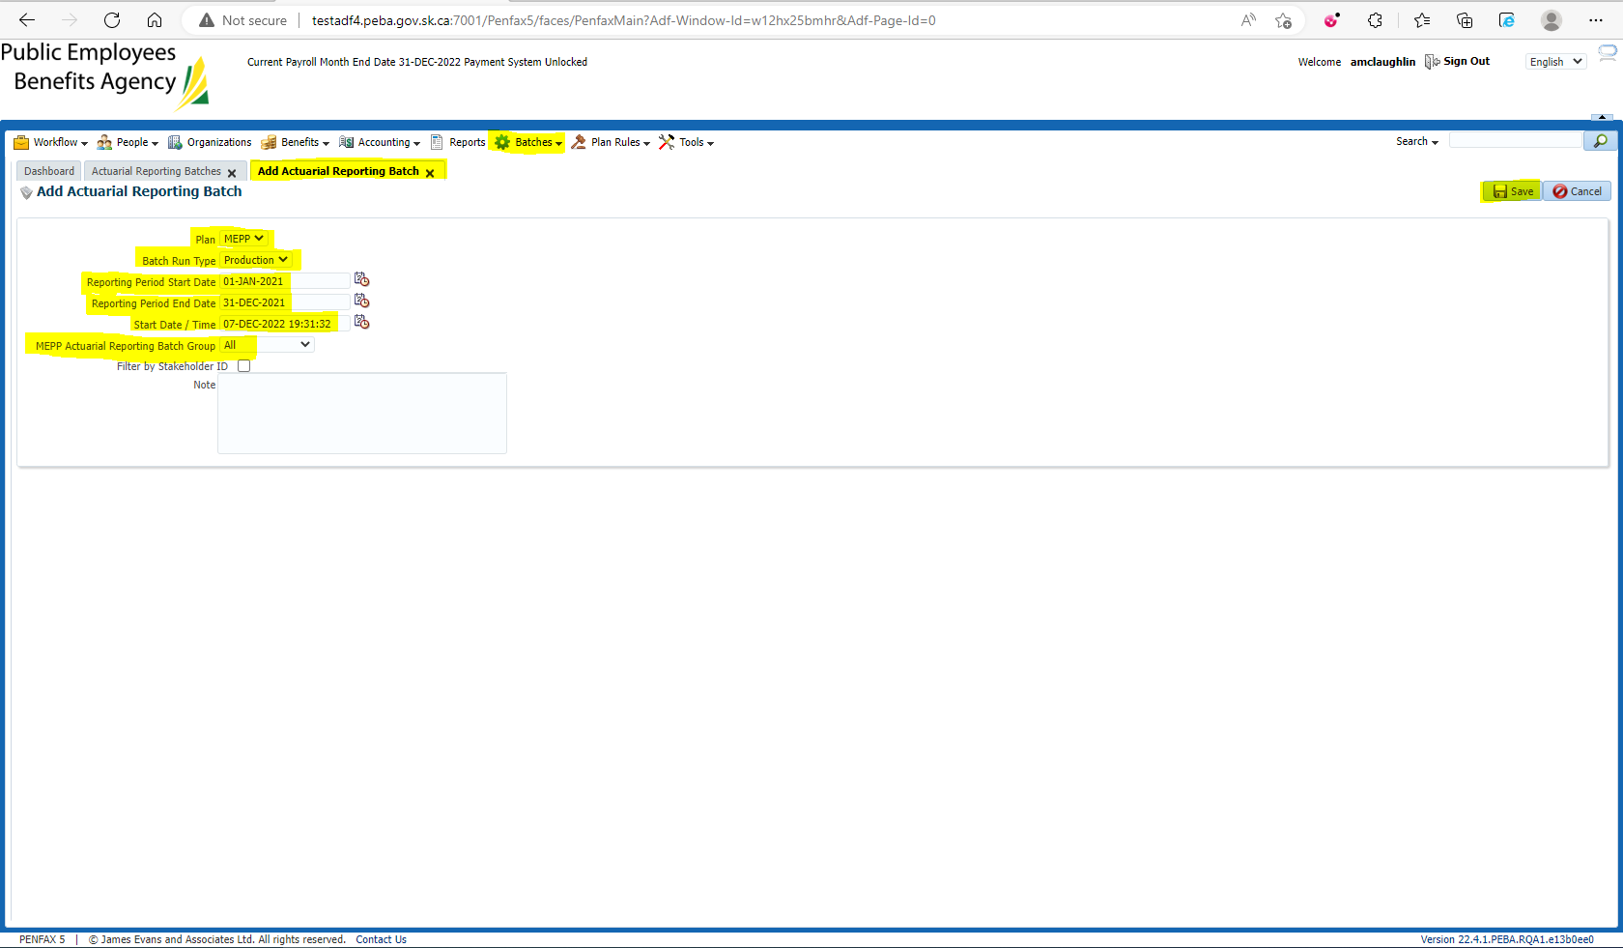

After the batch has run, Search for the batch and compare the run-time to similar batches to check for deterioration of performance, and then open the Batch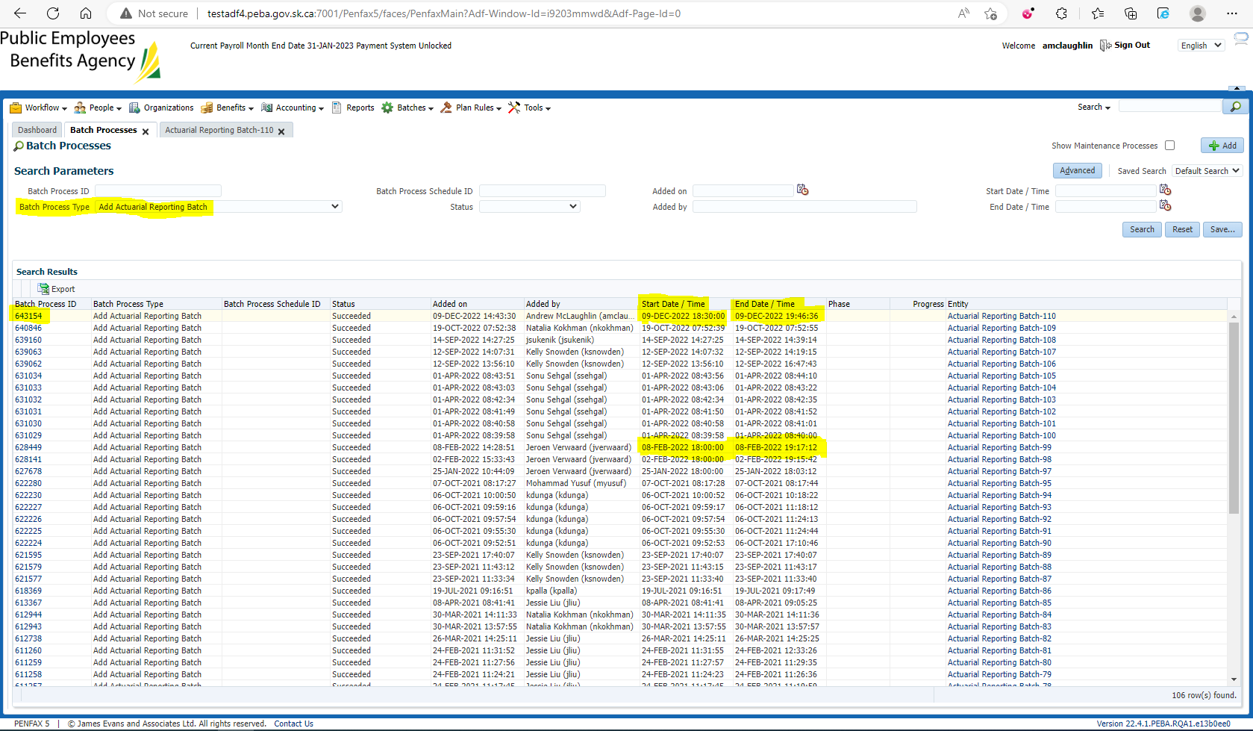

Check the files to ensure they have all been created 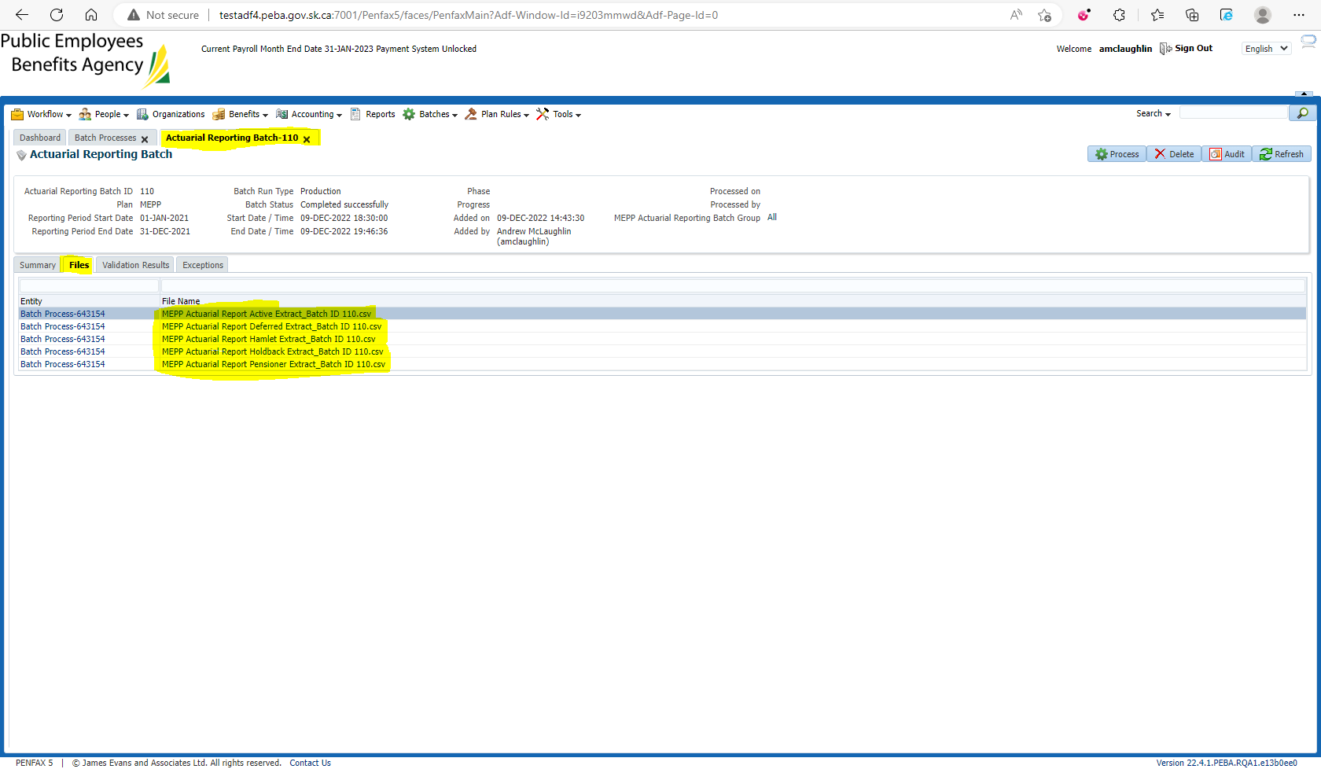

Validate the data in the files by comparing old data to new data in each spreadsheet and column. There should only be a small % change, and of the changed people, ensure there is a rational reason for the changes 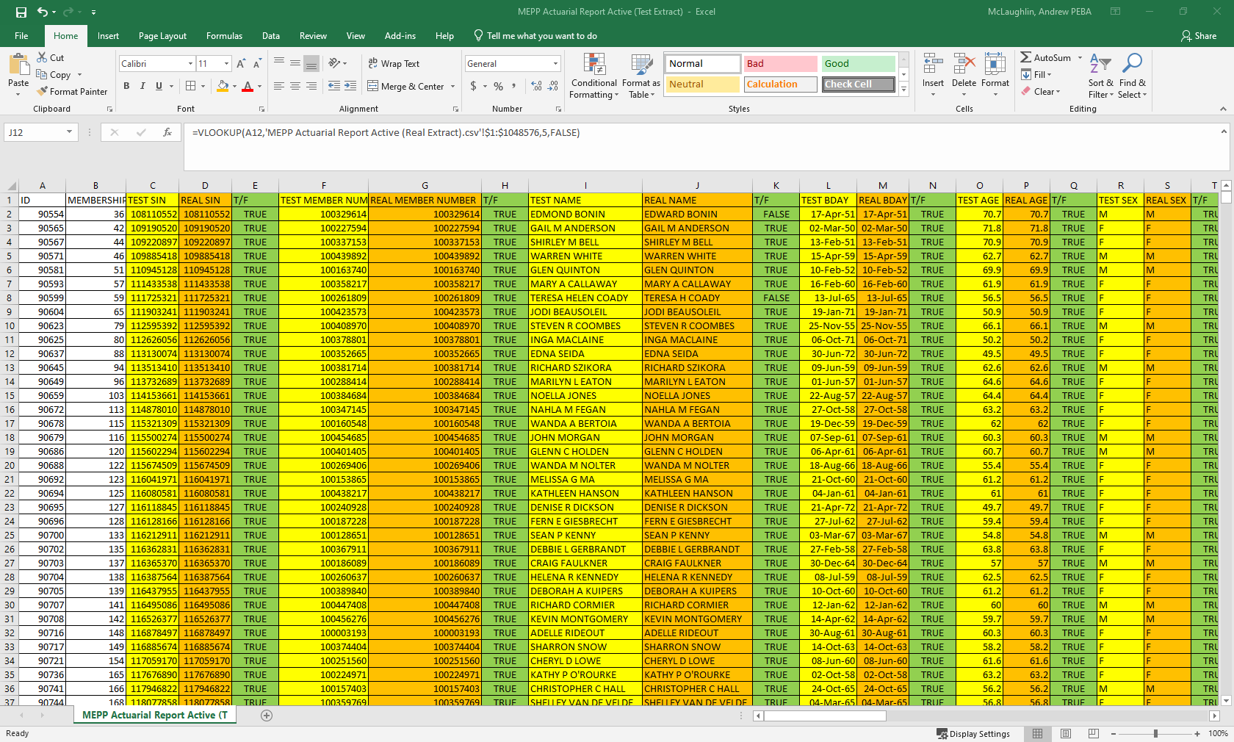

Ex. Data change for ID 292276